OYSTER RECIPES

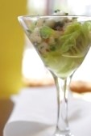

The Tsarina Oyster & Caviar Martini
Ingredients:
1/2 cup minced shallots
4 tablespoons chopped fresh dill
1/4 cup champagne vinegar
Juice of a fresh lemon
2 tablespoons fresh, coarsely ground black pepper
36 Fresh “Shucking Oysters” in shell
Crushed ice
2 ounces (60 grams) Beluga caviar
Method:
In a small bowl, mix the shallots, dill, vinegar, lemon juice, and ground pepper.
Shuck the oysters and with sharp knife separate the muscles from the shell.
Fill a large, wide-mouthed martini glass with crushed ice, then arrange the oyster shells on top with oysters replaced in shell. Spoon the sauce over the oysters and top with a dollop of caviar.
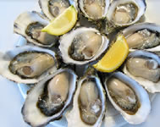
Natural Oysters:
Ingredients:
Oysters, Lime or Lemon wedge
Method:
Place freshly shucked “Shucking Oysters” onto a chilled plate and garnish with lime or lemon wedges.
Serve with a crisp white wine.
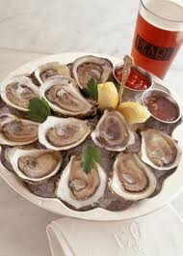
Oyster Shots:
Ingredients:
1 dash Tabasco Sauce
1 oz Tequila, “Shucking Oysters”
Salmon Pearls

Method:
Mix the Tabasco and Tequila, place freshly shucked oyster onto Asian spoon or oysters in shell on platter and gently pour tequila and tabasco over oyster. Garnish with salmon pearl.

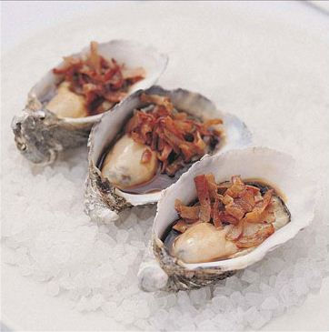

Oysters Kilpatrick
Ingredients:

12 “Shucking Oysters” shucked in the 1/2 shell
2 Lean bacon rashes chopped finely
2 tablespoons Worcestershire sauce.
Method:
Place the oysters in each of the ½ shell on a tray
Top with bacon, drizzle with sauce.
Place the tray under Grill or bake in oven for 5-10 minutes depending on your taste.

